Ideation Phase

Define the Problem Statements

|  |  |
| --- | --- |
| Date | 12/11/22 |
| Team ID | PNT2022TMID36315 |
| Project Name | Project –Car Resale Value Prediction |
| Maximum Marks |  |

# Customer Problem Statement Template:

Create a problem statement to understand your customer's point of view. The Customer Problem Statement template helps you focus on what matters to create experiences people will love.

A well-articulated customer problem statement allows you and your team to find the ideal solution for the challenges your customers face. Throughout the process, you’ll also be able to empathize with your customers, which helps you better understand how they perceive your product or service.

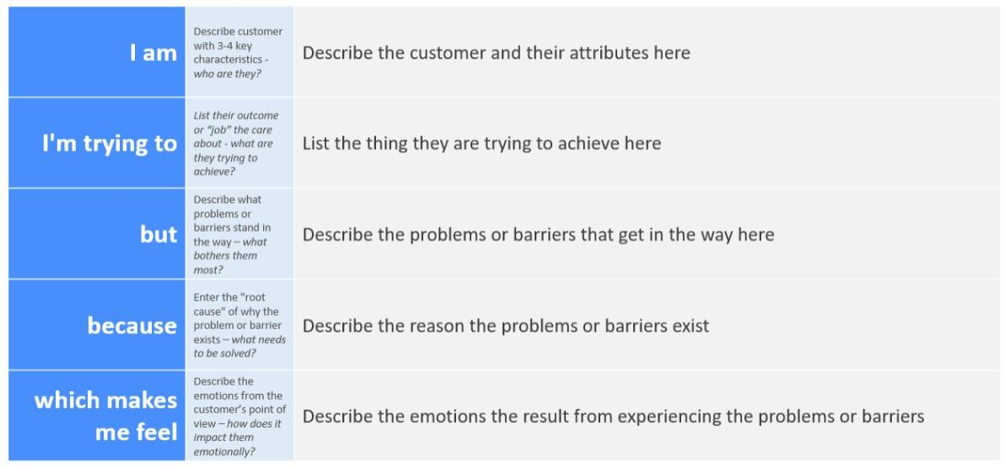

# Problem Statements for Car Resale Value Prediction

|  |  |  |  |  |  |
| --- | --- | --- | --- | --- | --- |
| **Problem Statement**  **(PS)** | **Iam (Customer)** | **I’m trying to** | **But** | **Because** | **Which makes me feel** |
| PS-1 | I am a graduate | I’m trying to resale a used cars | I can’t find an appropriate way to get old cars | I can’t able to collect the data of a good condition  car | Like I have no cars with a proper Mileage, condition, colour of the car,Accident History |
| PS-2 | And adult person  who lives in city | To use a car  for 10 - 60 | The user  would not | Because Its  important | Like to share a car with  others who have |

|  |  |  |  |  |  |
| --- | --- | --- | --- | --- | --- |
|  |  | minutes trips 1 -4 times per week | want to own his own car as it would be too expensive | for the user to think and live green and to not own more than he truly  needs | similar needs,there no easy and affordable solutions |
| PS-2 | I’m an average man | I’m trying to buy a resale car to save money and upgrade segment for less | I can’t able to analyse the full history of the used car | It may look at good condition, further may I get the upgrade segment in  high budget | Like I should not get a full analysis of the car and is there a chance to take a wrong decision. |

**Derived Problem Statement:**

User needs a way to buy/to be recommended to get more variety of cars at affordable cost, with good mileage, slower depreciation rates, cheaper insurance, upgrade segment for less and drive tension-free.